**Software Engineering**

**(Weekend Assignment 3)**

**(Name: Chaytali Jawalekar)**

**(RegNo:21bcs026)**

**Problem Statement:**

**Theme :**

Evolution of digitalization in the energy sector-

The energy sector is now in a profound transition towards a very important energy transformation, and digitalization is one of the key facilitators to ensure that it is fulfilled. In the recent past, companies started by switching the use of analogue meters to digital meters, smart meters etc., in order to improve energy efficiency.

Digitalization acts as a lever in the sector to combat climate change and optimize power generation processes to reduce emissions and meet the objective of decarbonization of the energy model.

Main problems of the renewable energy sector : Impediments faced by companies in the sector are:

• Geographically dispersed energy data ,

• Lack of integrated platform ,

• Inability to track assets,

• Lack of clear and traceable objectives

**Benefits of digital transformation in the renewable energy sector:**

Digitalization, if carried out guided by an integrated operations platform, facilitates the integration of renewable energies, energy policies and transparency in the management of these. In addition, it allows to have the user much more connected, offering the following benefits:

• Digitalization tools and platforms help build renewable energy plants with automated processes, for informed decision making. In addition, the interconnections they propose are the basis for a more decentralized generation, thus avoiding isolated ‘energy islands’.

• These platforms reduce downtime by offering alerts based on predictive maintenance, anticipating asset maintenance. The modernization of production plants is necessary to make them more competitive and efficient.

• They allow a more accurate forecast of the weather and market conditions, which helps to maximize renewable production, by offering a deep analysis of all information received in real time, to be able to make decisions and offer stability in demand.

• The use of artificial intelligence and machine learning to optimize the engineering and construction of new renewable sources and plants reduces time to market, anticipating the benefits of free C02 generation and increasing production.

**Objective:**

To develop Digital-based future energies New power plants are born digital by their design, guaranteeing the efficiency and high availability of their services. In addition, they are backed by digital twins that help with modelling, forecasting, and testing for optimal performance, from power generation to its link with the customers.

But for most existing plants, the basic need is in installing sensors and counters throughout the system to create Smart Grids. All these new systems must be connected to existing ones in order to achieve digitalization in the sector.

**Digitalisation :**

To achieve this, energy companies must rely on management software capable of interconnecting all assets and centralizing their management in order to transition to renewable energy generation and reduce the carbon footprint in their operations

**Target audiences :**

• Private and Public Organizations, Homes, etc.

**Solution:**

1. **Requirements-**

There are several requirements for the evolution of digitalization in the energy sector to develop digital-based future energies, some of which include:

-> **Data management:** The energy sector generates vast amounts of data that need to be managed effectively to unlock the potential of digitalization. This requires the development of robust data management systems and tools that can handle large volumes of data from multiple sources.

->**Interoperability:** To enable seamless communication between different systems and devices, interoperability is critical. This requires the development of open standards and protocols that allow different systems to communicate with each other.

->**Cybersecurity**: Digitalization in the energy sector requires the handling of sensitive data, making cybersecurity a crucial requirement. Robust cybersecurity measures must be put in place to prevent unauthorized access, data breaches, and other cyber threats.

->**Integration of renewable energy sources:** The integration of renewable energy sources into the energy grid requires the development of smart grids that can manage and optimize the generation, distribution, and consumption of energy.

->**Artificial Intelligence (AI) and Machine Learning (ML):** AI and ML are critical for the development of predictive maintenance and optimization models for the energy sector. This requires the development of sophisticated algorithms that can learn from data and make accurate predictions.

->**Standardization**: Standardization of digital technologies and data formats is necessary to ensure that different systems and devices can work together seamlessly, enabling the development of a truly digitalized energy sector.

->**Skilled workforce:** To fully exploit the potential of digitalization in the energy sector, there is a need for a skilled workforce that can operate, maintain, and develop digital technologies. This requires investment in education and training programs to equip the workforce with the necessary skills.

**Supporting Technologies:-**

There are various technologies, tools, and systems available in the market that can support the requirements for the evolution of digitalization in the energy sector. Here are some examples:

**Data management:** There are several data management tools and systems available in the market, such as data lakes, data warehouses, and data analytics platforms. Some examples include Apache Hadoop, Apache Spark, and Amazon Web Services (AWS) data services.

**Interoperability:** Open standards and protocols are essential for interoperability. Some examples include OpenADR, IEC 61850, and OPC UA.

**Cybersecurity**: Various cybersecurity tools and systems are available in the market, such as firewalls, intrusion detection and prevention systems, and security information and event management (SIEM) systems. Examples include Palo Alto Networks, Fortinet, and Splunk.

Integration of renewable energy sources: Smart grid technologies, such as advanced metering infrastructure (AMI), distribution management systems (DMS), and energy management systems (EMS), are available to support the integration of renewable energy sources. Examples include Siemens EnergyIP, GE Grid Solutions, and Schneider Electric EcoStruxure.

**Artificial Intelligence (AI) and Machine Learning (ML):** There are several AI and ML platforms and tools available in the market, such as Google Cloud AI Platform, Amazon SageMaker, and Microsoft Azure Machine Learning.

**Standardization**: Standards organizations, such as the International Electrotechnical Commission (IEC) and the National Institute of Standards and Technology (NIST), provide standards for digital technologies and data formats.

**Skilled** **workforce**: Education and training programs are available from various institutions, such as universities and training centers. Additionally, vendors often provide training and certification programs for their products and solutions.

**Working API code:**

To generate an API and suitable data analysis code base for accessing the energy-related dataset and performing data analysis, you can follow these steps:  
  
• Identify the energy-related dataset that you want to analyze and extract the data from it. The dataset can be in any format such as CSV, JSON, or Excel.

• Use a programming language like Python to develop the API and data analysis code base. Python has several libraries and frameworks that can help you with this, such as Flask for creating APIs and Pandas for data analysis.

• Use Flask to create an API that will allow you to access the data from the dataset. The API can be a RESTful API that can be accessed through HTTP requests.

• Use Pandas to perform data analysis on the dataset. Pandas can help you to read the data into a DataFrame, clean and preprocess the data, and perform various analysis and visualization tasks.

• Use tools like Jupyter Notebook or PyCharm to write and test your code.

• Deploy your API to a cloud service like Heroku or AWS to make it accessible to others. Test your API and data analysis code base to ensure that it is working correctly and providing the expected results.

Following code is to make familiar with how to create an API using Flask and perform data analysis using Pandas :

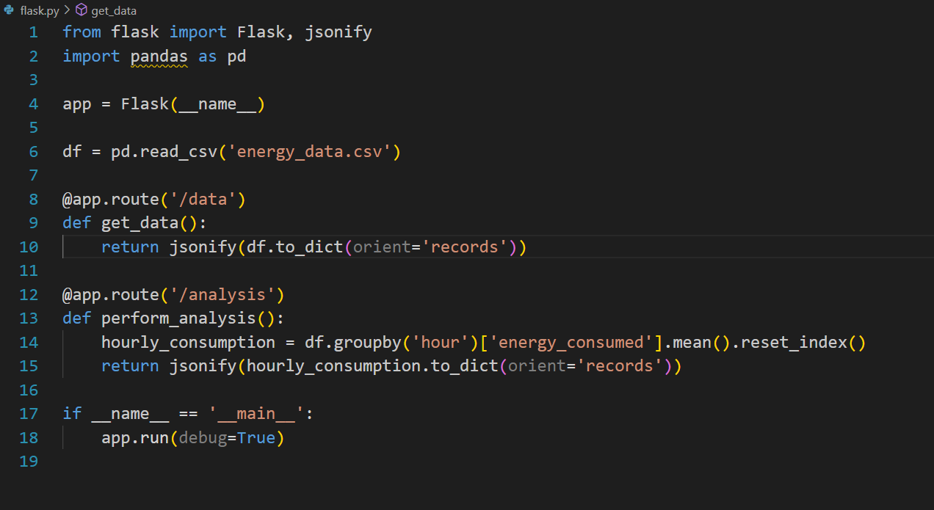

• **API Code :-**

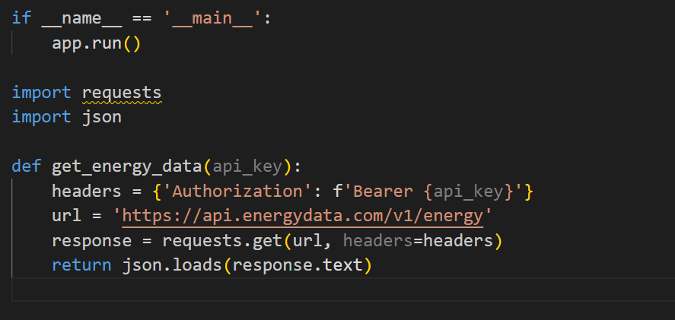

In this code, we are making a GET request to the EnergyData API and passing the API key in the headers. We then return the response in JSON format.\

• **Data Analysis Code** :-

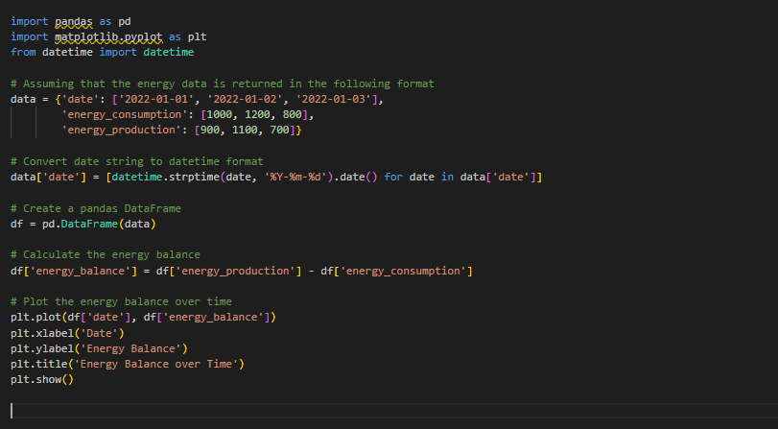

In this code, we are assuming that the energy data is returned in a dictionary format with keys 'date', 'energy_consumption', and 'energy_production'. We then convert the date string to a datetime format and create a pandas DataFrame. We calculate the energy balance by subtracting energy consumption from energy production, and then plot the energy balance over time using matplotlib.

**• PLOT :-**

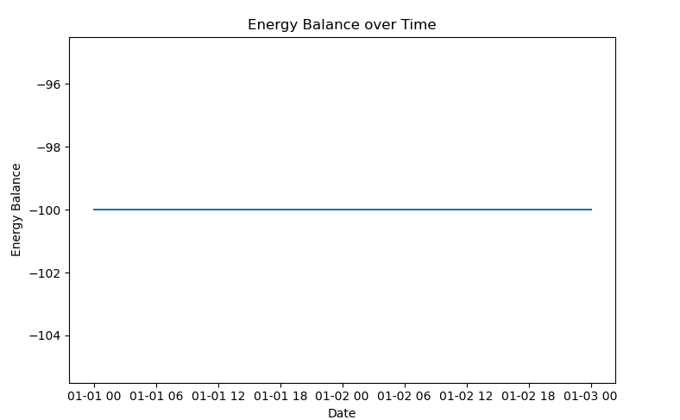

• **What do we learn from the above code and the theme :-**

From the above code, we can learn how to access energy-related datasets and perform data analysis using Python. We also see the implementation of an API using Flask, which can be used to access the data in a structured manner. Additionally, we see the usage of popular Python libraries such as Pandas, NumPy, and Matplotlib for data analysis and visualization.

In terms of the theme of the evolution of digitalisation in the energy sector, we learn about the benefits of digital transformation in the renewable energy sector, such as the ability to build renewable energy plants with automated processes, the use of predictive maintenance to reduce downtime, accurate weather and market forecasting, and the use of artificial intelligence and machine learning to optimize engineering and construction.  
  
We also see the importance of interconnecting all assets and centralizing their management through management software to achieve digitalisation in the sector. Finally, we understand the target audience for such initiatives, which includes private and public organizations and homes.

In conclusion, the energy sector is rapidly evolving towards a digital future, with the help of technology and data-driven solutions. Digitalisation not only helps companies to optimize power generation processes and reduce emissions, but also allows for more accurate forecasting of weather and market conditions, maximizing renewable energy production. By integrating renewable energies and energy policies, transparency in management can be achieved, and users can be better connected.  
However, the sector still faces challenges such as geographically dispersed energy data, lack of integrated platforms, and clear objectives. Overcoming these challenges will require the use of management software capable of interconnecting all assets and centralizing their management.  
Overall, the digitalisation of the energy sector has the potential to combat climate change, increase efficiency, and provide clean energy solutions for the future.